Overcoming space and time: detecting the effects of dynamic management on plant composition at the Tallgrass Prairie Preserve, OK.

McGlinn, Daniel^{1*}, Earls, Peter¹ and Palmer, Michael¹

Daniel McGlinn
¹ Department of Botany, Life Sciences East 117, Oklahoma State University, Stillwater, Oklahoma, 74078 USA; Email: daniel.mcglinn@okstate.edu
* correspondence author

Peter Earls
Email: earlsp@okstate.edu

Michael Palmer
Email: mike.palmer@okstate.edu

Running head: space, time, and disturbance
Abstract
Question: Is the plant species richness and composition of a tallgrass prairie undergoing change through time and space, and how much of this change can be attributed to management using fire and grazing?
Location: Tallgrass Prairie Preserve in Osage Co., Oklahoma, USA.
Methods: A tallgrass prairie was managed with randomized burning and bison grazing as well as with more traditional management of spring annual burning and cattle grazing since 1993. We annually sampled 100 m² square quadrats located in the grasslands of the preserve for all vascular plant species from 1998 to 2008. Multiple regression with ordinary least squares, generalized least squares, and mixed-effects were used for explanatory modeling and variation partitioning of species richness. Indirect and direct gradient analysis was used to understand the variation in plant composition at this preserve. We utilized partial canonical correspondence analysis (pCCA) and variation partitioning to quantify the partial and shared variation that space, time, and disturbance variables had on species composition.
Results: There was significant change though time in species composition; however, this change was non-directional. Partial disturbance effects only explained 1.9 % of the total inertia which was less than the percent explained by site identity (48.9 %) and year of sampling (4.4 %). The large degree of variation that site identity explained was related to the pH gradient. Plant functional groups differed predictably in their responses to various aspects of management.
Conclusions: Variation in space alone explained a large degree of the variation in plant composition. Therefore, it is important for restoration projects to be designed and interpreted with respect to the relevant spatial environmental gradients.
Keywords: Tallgrass prairie, Canonical correspondence analysis, variation partitioning, restoration ecology, diversity, Osage County, Oklahoma.
Nomenclature: USDA Plants database (2005)
Introduction

Natural variability concepts of land management, which promote spatial and temporal variability, are increasingly utilized in restoration ecology (Palmer et al. 1997). Underling these concepts are two premises: 1) that historical conditions and processes can provide guidance for management, and 2) that spatial and temporal variability generated by disturbance are vital components of nearly all ecosystems (Landres et al. 1999). Managing for historical conditions is thought to benefit species that have evolved in that system and to minimize human alternations (Swanson et al. 1994), and spatial and temporal variability is thought to maintain biological diversity (MacArther 1965, Petraitis et al. 1989). Although these concepts are grounded in ecological theory, Palmer et al. (1997) notes, the importance of managing for natural variability are rarely examined experimentally.

The application of natural variability concepts is relevant to the conservation and restoration of the North American tallgrass prairie ecosystem. In this ecosystem fire and grazing were important components of disturbance regime in pre-Columbian North America (Anderson 1990) and still are today (Daubenmire 1968, Abrams et al. 1986, Collins 1992). Although historically the region was grazed by Bos bison L. (bison) and was burned in a variety of seasons, presently much of the remaining tallgrass prairie ecosystem is managed for cattle with annual spring burns (Fuhlendorf and Engle 2001) . The purpose of annual spring burning in is to maximize yields of palatable C4-grasses (Towne and Owensby 1984). Howe (1994) also noted that many restoration efforts on prairie remnants promote production of C4-grasses with spring season burning and a lack of grazing. These management practices may be a threat to the ecosystem’s biodiversity by only benefiting one competitively superior plant-functional group and by homogenizing an entire region’s disturbance regime (Howe 1994, Fuhlendorf and Engle 2001, Nekola and White 2002).

In an effort to restore natural variability to grazing systems, Fuhlendorf and Engle (2001, 2004) suggested the interaction between fire and grazing could be used in a more variable manner in space and time to create a shifting mosaic in contrast to the traditional homogenous application of these management tools. They argued that a mosaic of burned and unburned patches more closely approximates the historical variability that would have existed on the landscape and will result in higher biodiversity then traditional homogenous management practices (annual spring burning). This hypothesis is guiding the management of the Tallgrass Prairie Preserve (TGPP), the largest preserved tallgrass prairie in the world (Hamilton 1996, 2007).

The scale of this particular preserve (15,700 ha) coupled with the spatial and temporal variability of the large-scale treatments, in which entire watersheds are burned, provides both important opportunities and challenges for experimentally evaluating aspects of the natural variability hypothesis. One of the opportunities that this particular preserve offers is the ability to investigate the relative importance of management in a tallgrass prairie ecosystem that is presumably in somewhat of a more pre-Columbian (‘natural’) state given the intact native vegetation, the presence of free ranging bison, and the non-fixed burning regime is implement on the preserve. This opportunity is valuable because the majority of our knowledge on tallgrass prairie ecology either originates from relatively small scale treatment plots or strictly controlled watershed treatments (e.g., Konza prairie LTER). Controlled studies are extremely valuable in elucidating ecological mechanisms that underlay prairie ecology, but they may be less useful in providing the ability to examine the influence of management within a broader ecological context (Halle 2007, Weiher 2007). However, this opportunity is also a challenge…A key challenge of making statistical inferences from non-controlled systems is developing a sampling design with adequate power that can capture the variability of the ecological community and the signature of management treatments. Additionally, a statistical analysis must be developed that is tolerant of non-balanced treatments (i.e. variable management through time) and temporal autocorrelation given that inferences in these systems are often more meaningful when considered through time (ref.). However, these data-analytical challenges are not unique to this study system. A key aspect of management plans on many nature preserves is flexibility; therefore, it is often not logistically feasible or pragmatic to establish controlled landscape scale experiments ref. Therefore, these challenges can also be viewed as an opportunity to demonstrate sampling and analytical methods that are useful for drawing inference from the non-controlled experimental setting that the Tallgrass Prairie Preserve offers (Legg and Nagy 2006, Murray and Conner 2009).

With these opportunities and challenges in mind, the purpose of this study was to investigate the variation in plant species richness and composition in space and time at the TGPP, and to detect the relative importance of management using prescribed burning and grazing by bison and/or cattle. As noted above a randomized block design of burning and grazing treatments is not easily implemented on the preserve, and therefore our study is observational in nature. Differences due to management within a sample are likely to be strongly confounded by year-to-year variation in climate (Anderson 1982), variation in soil (Critchley et al. 2002), and variation in topography (Briggs and Knapp 1995). However, these confounding variables can be used as covariables in multiple regression and partial canonical correspondence analysis (pCCA; Borcard et al. 1992) so that the amount of variation only explained by management can be quantified relative to other explanatory variables.

Using a mixture of explanatory modeling and ordination techniques we addressed three related questions. Is there directional change in species richness and species composition through time? What are the most important environmental variables for explaining plant richness and composition? If space and time are factored out does disturbance significantly correlate with richness or composition and in what way?
Methods
Study Site:
The TGPP is a 15,700 ha nature preserve located between 36.73° and 36.90° N latitude, and 96.32° and 96.49° W longitude, in Osage County, Oklahoma and owned by The Nature Conservancy (TNC). The preserve is situated at the southern extent of the Flint Hills region. The elevation of the preserve ranges from 253 to 366 m, and the underlying bedrock of the region is characterized by soils deriving from Permian sediment (Oviatt 1998). Due to long-term erosion, the surface layers of soil are thin and young; limestone and sandstone are frequently exposed at the surface, sometimes within close proximity of each other. Because of this rockiness the Flint Hills region, including the Tallgrass Prairie Preserve, has remained unplowed and has been instead utilized primarily as rangeland for cattle. Prior to the acquisition of the preserve by TNC in 1989, the majority of the site was managed for cow-calf and yearling cattle production with a 4- to 5-year rotation of prescribed burning and aerial application of broadleaf herbicides (1950-1989) (Hamilton 2007).

Approximately 90 % of the TGPP consists of grasslands. The majority of the grasslands are composed of tallgrass prairie habitats dominated by Andropogon gerardii, Sorghastrum nutans, Sporobolus compositus, Panicum virgatum, and Schizachyrium scoparium. Shortgrass prairie habitat occurs to a lesser extent on more xeric sites and is dominated by Bouteloua spp. Despite the application of herbicide earlier in the century the flora of the preserve appears relatively intact with a total of 763 species of vascular plants (to date) of which 12.1% are exotic (Palmer 2007).

Management:
The management at the TGPP was variable in space and time. In 1993, 300 Bison bison (bison) were introduced year-round onto a 1,960 ha portion of the preserve (Hamilton 1996, 2007). As the bison herd increased in size, the area allotted to the herd was increased eight times to an area of 8,517 ha by 2007 (Fig. 1, 54% of preserve area). Within the bison unit animals were allowed to range freely and their movement was not obstructed by internal fences. Watersheds within the bison unit were considered randomly for burning only if they met the minimum fuel criteria of 900 kilograms per hectare of fine fuels. Within a given year, the season of burn of the bison unit was split as follows: 40 % dormant spring (March - April), 20 % late growing season (August - September), and 40 % dormant winter (October - December); however, this was only a general prescription and prone to variation as well (Hamilton 1996, 2007). The remainder of the preserve was seasonally grazed by cattle and typically burned more frequently in the dormant spring season, but some of the cattle pastures were utilized for smaller scale (2,350 ha) patch-burn experiments in which only one-sixth of a given management unit was burned annually (Hamilton 2007). Stocking within the cattle pastures included both intensive-early stocking and season-long stocking.

Data collection:
Because of the temporally variable and spatially aggregated nature of the management, we opted to annually re-sample a semi-random, spatially stratified set of twenty square 100 m² plots located at the intersections of the 1-km UTM grid. The only criteria that we imposed on the selection of our plots was that they contain less than 20 % of woody cover, standing water, or exposed rock. An un-biased spatial stratification of samples is an ideal sampling method for ensuring that samples are an unbiased representation of the broader variation in grassland communities across the preserve. Also an assumption of spatial independence is justifiable, with our design, given that the minimum distance between any two samples (1000 m) is almost two orders of magnitude larger than the maximum distance captured within a given sample (≈14.14 m). Long-term resampling of our plots allowed us to: 1) observe vegetation in multiple management states (e.g., one year post burn, bison vs. cattle grazed), 2) consider the role of management after considering year to year variation. We resampled our plots every June from 1998 to 2008 and recorded the percent cover of all vascular plant species. Each year we combined four 10 cm soil core samples for each vegetation sample and sent these to Brookside Labs (New Knoxville, Ohio) to be analyzed for soil cations, pH, and other variables. We recorded topographic data on slope and aspect in the field. For analyses, aspect was converted in a measurement of northness [northness = cos(aspect)] (Roberts 1986). We did not consider a corresponding index of eastness because of difficulties in ecological interpretation and exploratory results indicated it was unimportant (not shown). Total monthly rainfall and average monthly temperature data was downloaded from the Oklahaoma Mesonet Foraker site (36.840530° N, -96.427770° W; 330 m) which is located on the preserve (McPherson et al. 2007). Additionally, 1-month Self Calibrating Palmer Drought Severity Index SC-PDSI (Wells et al. 2004) was downloaded from the Greenleaf Climate database from the Pawhuska weather station (36.669° N, -96.347° W; 255 m) which was approximately 20 kilometers south of the Foraker mesonet tower (Anon. 2008). We derived management variables including years of bison grazing, years since last burn, and number of burns in the past five years from a GIS database that we developed based on TNC’s recorded burn and grazing history. We recognize that the number of burns in the past five years is correlated with years since last burn (appendix #) and reflects somewhat of an arbitrary cutoff point (five years), but we chose to include this variable in our models despite these shortcomings because we wished to quantify the short term burn history of a site. If a site is burned frequently then years since burn does not convey any information on the history of the site. It is important to note that all of these management variables are dynamic in time, meaning that that there were not fixed treatments.
Data analysis:
Our goal when modeling richness and species composition was primarily to develop explanatory models and not predictive models, sensu Mac Nally (2000). Therefore, we were primarily concerned with comparing the explanatory strength of variables that were chosen a prori rather than developing the a single most accurate or necessarily most parsimonious model/s. For dissecting relationships between species richness and our various explanatory variables we utilized ordinary least squares (OLS), generalized least squares (GLS), and linear mixed-effect (LME) multiple regression models. Both GLS and LME models were fit with maximum likelihood. In order to account for within-sample temporal autocorrelation we incorporated a first-order autoregressive term in our GLS and LME models. Our LME models allowed us one additional level of complexity in that we could model within sample effects as random effects and the between sample effects as fixed effects. This was beneficial because… To our knowledge, autoregressive terms and mixed-modeling methods have yet to be developed theoretically with respect to ordination and therefore these methods were not mirrored in our analysis of species composition.

We used two related but complementary procedures to examine the relative importance of our explanatory variables with respect to species richness: variation partitioning and hierarchical partitioning. Variation partitioning (or commonality analysis) was utilized to estimate the unique and shared fractions of explained variation in three factors (or classes of variables): sites, years, and management (Legendre and Legendre 1998, Peres-Neto et al. 2006). Sites and years were quantified simply as dummy variables and the management factor was composed of the three management variables described above. Partitioning was carried out with OLS as well as with GLS multiple regression. For each fraction for the OLS analysis, we report both the coefficient of determination and its adjustment for number of variables, 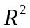 and 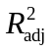 respectively. For the GLS fractions we calculated a generalized formulation of the coefficient of determination, 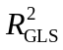, that is appropriate for models fit via maximum likelihood (Nagelkerke 1991). We conducted conditional F-tests for the unique fraction of each factor using only the GLS model which was more conservative than the OLS given that it corrected for the temporal autocorrelation in the dataset. Hierarchical partitioning was used to rank explanatory variables relative to one another in only the OLS modeling context (Chevan and Sutherland 1991, Murray and Conner 2009). The estimates of the independent and shared fractions of explained variation represent the average difference in explained variance in all possible 2^{K} models where K is the number of variables compared. We chose to compare the strength of seven variables overall (128 possible models). Three of the variables were site specific: log Ca, slope, and northness. Although several year specific variables were initially considered, only an annual average of monthly SC-PDSI (year defined as June 1 to May 31) was retained for the final comparison. All three management variables were included in this comparison. We implemented hierarchical partitioning with the R package hier.part (Walsh and Mac Nally 2008).

In all the analyses we treated species richness as a continuous variable with normally distributed error. We recognized that in some modeling contexts it is more appropriate to consider richness as a Poisson distributed variable (rather than a normal one) (Candy 1997, Palmer and Hussain 1997). However, because the normal distribution provides a good approximation of a Poisson random variable when the mean is larger than approximately 20; we feel that our usage of normal errors (instead of Poisson) is justified given that richness was never below 48 in our samples. We also recognize that some authors consider richness to only be one facet of grassland biodiversity and that other diversity indices can yield more insight into the ecology of the system (Wilsey et al. 2005, Chalcraft et al. 2009). This may be potentially true, but in this study richness was so strongly correlated with all of the indices examined in Wilsey et al. (2005) that additional analyses on various diversity indices would have yielded little additional insight (See appendix #).

We utilized both indirect and direct ordination methods to examine changes in species composition. Prior to all ordinations, we square-root transformed all species cover data, down-weighted rare species, and log-transformed the soil variables (Palmer 1990). Detrended Correspondence Analysis (DCA; Hill and Gauch 1980) was used to visually inspect directional change in the plant composition through time for all three subsets of the data and to get an estimate of the amount of variation the species displayed across a hypothetical environmental gradient. Non-metric multidimensional scaling (NMS), another indirect ordination technique that in contrast to DCA does not assume the existence of a hypothetical environmental gradient, was used to confirm the general conclusions of the DCA. Partial canonical correspondence analysis (pCCA) was used to perform variation partitioning on space, time, and management variables (Borcard et al. 1992, Okland 1999). We used site identity as a controlling variable for spatial variation and year of sample as a controlling variable for change through time. All management variables were included in this analysis. Site identity and year of sample were specified as dummy variables. We calculated Peres-Neto et al.’s (2006) formulation of the adjusted fraction of variation explained in CCA using a permutation approach (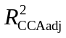). Monte Carlo randomization tests were used with 999 iterations to determine significance of all canonical axes for all partial CCA analyses under the reduced model (Legendre and Legendre 1998). These randomizations were constrained by strata which consisted either of site or year depending on the explanatory variable of interest. If site was specified as the strata then permutations were toroidal shifts in which the observed order (i.e. temporal structure) of the data were maintained, but if year was specified as the strata then permutations were at random between sites. Specifying site and year effects as dummy variables provides simple general interpretations, but we were also interested to see if any of the variables we measured explained between or within site variability in composition. We chose to examine the relative importance of log Ca, slope and northness for explaining between site differences. We preformed multivariate analyses with CANOCO version 4.5 and the R package vegan (ter Braak and Šmilauer 2002, Oksanen et al. 2008, R Developmental Core Team 2008).

Results
Variance in species richness
The average species richness over the 11 year study was 76.24 (± 0.86). The within site variance (σ = 9.13) in richness was approximately equal the between plot variance (σ = 8.93). There was not strong directional changes in total richness (not shown ) or in the four functional groups we recognized (Fig. 2). Forbs were significantly more rich than all other functional groups. Variation partitioning based on the unbiased estimate of variance explained by OLS, R²-adjusted (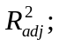Table 1), indicated that between site differences accounted for the majority of the variance in richness (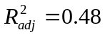), followed by year-to-year differences (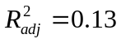). However, after the within-site temporal autocorrelation was considered (using a first-order auto-regressive term); plot identity and year identity explained equal fractions of unshared variation according to Nagelkerke’s (1991) generalized definition of the coefficient of determination (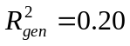). In both OLS and GLS based variation partitioning, the management class of variables accounted for a much smaller percentage of explained variance in richness (4%), but still contributed a significant amount of explained variation as judged by conditional (type III) F-tests at an alpha level of 0.05 (Table 1). The shared component of variation between management and site was larger than the influence of management alone, but the same was not true when comparing year and management after correcting for temporal autocorrelation in which case the shared component was effectively zero.
Hierarchical partitioning on OLS based R² values indicated that the most important site variable was log Ca which was negatively correlated with richness (Fig. 2). The next most important variable was years of bison grazing. The other variables had approximately equal independent and shared components. It is important to note that for all the variables considered there was a sizeable shared component of variance relatative to each variables independent effect. This indicates that many of the variables are collinear with each other.
Variance in species composition:
The DCA indicated that there was non-directional change in species composition through time (Fig. 3). Furthermore, samples remained relatively separate from one another in ordination space which indicates that variation in species composition was greater between plots than within plots. There was not a strong difference in samples scores between plots that were bison versus cattle grazed along the first and second DCA axes. Furthermore, when samples switched from cattle to bison their trajectory through time did not substantially change. The results of the NMDS (not shown) corroborated these qualitative results.
Variation partitioning based upon CCA indicated that site effects explained the majority of the variation in species composition (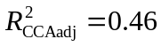, Fig. 4). Year and management effects on species composition were negligibly small after adjustment, but both were still found to be significant in randomization tests at the 0.05 level (Table 2). There was a somewhat large shared site and management fraction (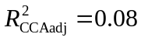) of explained variation. This suggests that the majority of management effects were site specific. The pCCAs that considered site specific explanatory variables after factoring out year and management effects indicated that log Ca was the most important site specific variable (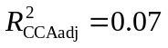; Table 2).

Although management explained only a very small proportion of the variation in species composition, we feel that for applied purposes it is still worth examining the management effects on particular species using a pCCA biplot (Fig. 5). The pCCA biplot displays the 90 most abundant species (out of 307 total) with respect to the three management variables after factoring out year and site effects as dummy variables. It appeared that both C3 and C4 grasses (open and filled black circles on biplot respectively) appeared to decrease in cover with increased years of bison grazing. The invasive species, Lespedeza cuneata (sericea lespedeza) was positively correlated with years of bison grazing. However, this species is a specific target species for herbicide application by the TNC so care must be taken in interpretation of this result. Annual and ruderal species such as Chamaesyce nutans (eye bane), Plantago virginica (Virginia plantain), Ambrosia artemisiifolia (annual ragweed), and Andropogon virginicus (broomsedge bluestem) appeared to be positively associated with the number of burns in the past five years. Discussion
The purpose of our study was to examine the influence of a variable management regime on plant richness and composition relative to site-to-site and year-to-year variability. Our results suggested that our samples are not undergoing strong directional changes in richness or composition through time (i.e. they do not appear to be on a clear trajectory). Rather, samples appear to maintain their differences over time and respond somewhat idiosyncratically to management effects. This is not to say that we did not detect significant management effects on richness and composition that independent of site and year effects, but simply that the management effects were relatively unimportant relative to these other sources of variation.
Drivers of site-to-site variation
The bulk of the variation in richness and composition was due to differences between sites which we believe primarily reflects belowground differences between our samples. We found that Ca explained the predominant amount of site-to-site variability in both richness and composition (Fig. 3, Table 2). We interpret Ca’s importance to be due to its role as a proxy variable for many other soil properties which are generally indicative of limestone derived soils (following, Palmer et al. 2003, Brokaw 2004). Using the same 20 plots analyzed in this study (only for the year 2002), Brokaw (2004) found that out of a set of 12 different soil nutrients and total carbon that the two most important variables for explaining plant composition (using pCCA) were total C (C_{t}) and recalcitrant P (P_{r}). Both of these soil variables were positively correlated with Ca and when compared to two other soil cations (Fe and Zn) as well as slope, C_{t} and P_{r} did not explain a significantly different portion of variation in composition (i.e. they were redundant with the other variables). Brokaw (2004) also found that C_{t} was strongly positively correlated with the majority of soil nutrients and a general indicator (like Ca) of limestone parent materials which tend to be more productive (ref.). These findings suggest that the important role that Ca played in our study does not necessary contradict the large body of work that suggests that below ground nutrients are the predominant drivers (not cations) of plant richness and composition in tallgrass prairie ecosystems (Turner et al. 1997, Burke et al. 1998, Baer et al. 2003, 2004).

The positive relationship between Ca and soil nutrients (that Brokaw [2004] found in our samples) suggests that stronger competitive exclusion on the more productive sites may explain the negative relationship between richness and Ca that we observed in our study. Given the multi-scale sampling that we carried out in our sites it is tempting to examine if the strength of Ca as an explanatory variable increases for smaller scales where we expect competitive exclusion to be playing a stronger role. However, this would be a misguided analysis because we expect the noise-to-signal ratio to be much higher in our smaller plots and we should expect to see a decrease in the ability of any explanatory variable (that is not collected in a scale specific manner) at smaller scales. Partel’s (2002) species pool hypothesis offers an alternative hypothesis for the negative correlation between richness and Ca (Palmer et al. 2003). The species pool hypothesis postulates that negative correlations between richness and pH (or Ca given their tight correlation) will occur in regions in which habitats high in pH were evolutionarily scarce. Palmer et al. (2003) found that the data from the Tallgrass Prairie Preserve (including some of this study’s plot) appeared to support Partel’s hypothesis in the grasslands but not in the woodlands.
Although only a small portion of the variability in richness or composition was explained by topography, the strength and direction of the relationship between richness and northness may be relieving. The degree of northness in temperate plant communities is often associated with less solar radiation which may explain the positive relationship between northness and richness in our study system. Much of the diversity in the tallgrass prairie is in the forb community which are C3-photosynthetic (Fig. 2) and may be more favored on the more protected north-facing hill sides (ref). This line or reasoning suggests that there may be a positive interaction between slope and northness with respect to richness (i.e. north facing slopes that are steeper are even more shaded from the sun and therefore better habitats for forbs), but we did not find evidence for this relationship (not shown).
Independent management effects
Our results indicated that the management variables were significantly correlated with plant richness and composition; however, that their effect was relatively minor in comparison to the inherent spatial heterogeneity of the samples. Years of bison grazing appeared to be the most important management variable with respect to both richness and species composition (Fig. 3). The importance of this variable must be considered carefully though, because bison management units were managed differently than cattle management units. Specifically, the average fire return interval was set at approximately 3 years in the bison units which was generally longer than in cattle units (Hamilton 2007). Also the bison units are grazed year round, while the cattle units are only seasonally grazed. Therefore, although we are fairly confident that the length of time a sample has occurred within the bison unit is positively correlated with its richness, we are less confident that this is due actually to the presence of bison in comparison to cattle.
It has been hypothesized that the presence of bison increases the richness of vascular plants because they selectively forage on graminoids rather than forbs (in contrast to cattle which behave more as generalists) (ref.). This dietary behavior is hypothesized to release the forbs from competitive exclusion from the dominant C4 grasses. The pRDA biplot (Fig. 4) on the richness of the plant functional groups indicated that all functional groups tended to increase in richness in the bison grazed sites except the C4 grasses. Although we did not record data on the total cover of each functional group, the pCCA biplot (Fig. 7) suggested that years of bison grazing was negatively correlated with the cover of the majority of C3 and C4 species. Both of these findings lend modest support to the hypothesis that bison may increase richness of tallgrass prairie by decreasing the cover of graminoids. Towne et al. (2005) undertook a more controlled approach to investigating the effects of bison and cattle grazing on plant richness and composition at the Konza tallgrass prairie over a 10 year period in annually burned pastures. They also found that overall the differences between bison and cattle were slight but that bison grazed patches had a higher cover of some forb species and gained forb species through time at a more rapid rate. Towne et al.’s general conclusion that the differences reported between cattle and bison grazing in the literature may be predominately due to differences in management of the units and not due to inherent differences between these two grazers certainly may apply to our findings as well.
Management implications:
The purpose of our study was not to directly test whether or not variable management regimes are effective tools for meeting conservation targets (this would require a study design that clearly differentiated between variably managed units and non-variable units (Brooks et al. 2002, Fuhlendorf and Engle 2004, Fuhlendorf et al. 2006)), but rather to examine the relative influence that management has on the plant community in which the management is guided by the natural variability hypothesis. The primary implication that our study is that the importance of the template or inherent site-to-site heterogeneity cannot be neglected when testing ecological theory, setting conservation goals and evaluating progress. We recommend like some other authors that restoration targets must be viewed within the context of the important environmental gradients that shape community composition (White and Walker 1997, Nekola and White 2002). In tallgrass prairie systems, fire and grazing are extremely important management tools (Collins et al. 1998); however, we warn that small scale experimental studies that simply show the significance of fire and grazing variables on plant functional groups may be overlooking the larger spatial context that ultimately determines whole community composition. Future tallgrass prairie preserve design in the Flint Hills region should strongly consider capturing as much of the limestone to sandstone gradient as possible, in order to capture a larger degree of complementarily in plant species composition.
Experiments in non-controlled systems:
One of the challenges/opportunities in examining the influence of management at this preserve was that it was variable through time. It is important to recognize that even without control treatments that observation studies can provide vital information about the ecology of a system (Legg and Nagy 2006). We demonstrated that one method for examining
Conclusions:
- Site-to-site differences in soil related to a limestone-sandstone differences explained the majority of

Acknowledgments
We thank Bob Hamilton, Jayne Salisbury, Kindy Chang, Sandy Earls, Sandy Stevens,
Kerry Sublette, James Shaw, Sonia Jaiswal, Chris Sellers, Norman Elliott, Wade French, Suzanne McAlister, Eric Maichak, Ronald Tyrl, Steven Thompson, Reinhard Spiegelhauer, David Nemcock, Linda Gatti-Clark, Karol Ezell, Kevin Belt, Marissa Raglin, Thomas Wohlgemuth, Chris Hise, Dai-Jun Zhang, John Wilson, Jerry Husak, Larry Thiesen, Joshua Brokaw, Jerad Linneman, Ken Hobson, The Oklahoma State University College of Arts and Science, The Oklahoma Nature Conservancy, The Spatial and Environmental Information
Clearinghouse, The Philecology Trust, The Swiss Federal Institute for Forest, Snow and Landscape Research, and the Oklahoma Water Resources Research Institute for assistance at various stages of research at the Tallgrass Prairie Preserve.
References:
Tables
Table 1. Variation partitioning of richness into the its components for site (S), year (Y), and management (M) variables. Note that the factors: site, year, and management consist of q explanatory variables. For the site and year factors these variables were simply dummy variables (see Methods for explanation). The partitioning was conducted with respect to the unadjusted and adjusted OLS coefficients of determination (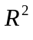and respectively), as well as, as coefficients of determination for GLS models incorporating a single autoregressive term (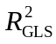). The conditional F-tests (approximate tests) are reported only for the GLS models.
 | OLS |  |  | GLS (AR1)
Factors (q) |  |  |  |  | F-ratio | p-value
S | Y U M (19) | 0.48 | 0.48 |  | 0.27 | 13.4791 | < 0.0001
Y | S U M (10) | 0.13 | 0.13 |  | 0.18 | 10.27 | < 0.0001
M | S U Y (3) | 0.04 | 0.04 |  | 0.02 | 7.25 | 0.0001
S ∩ Y | M | 0.01 | -0.02 |  | 0.25
S ∩ M | Y | 0.05 | 0.05 |  | 0.04
Y ∩ M | S | 0.08 | 0.07 |  | < 0.01
S ∩ Y ∩ M | -0.01 | -0.02 |  | < 0.01
Total (32) | 0.77 | 0.74 |  | 0.77

Table 2. The conditional explanatory power of several measured variables on species richness. The variables site, year, and management are as defined in Table 1. The model used to account for within site temporal autocorrelation in the residuals is displayed with the estimated range and nugget (See methods for details on the selection of the correlation model). Cells marked as “--” indicate that their values are identical to cells above. The standardized regression coefficient (β) is also given to indicate the strength and direction of the response of richness, as well as an estimate of variation explained, and conditional F-tests (approximate tests).
Explanatory Variables | Covariables | Temporal Autocorrelation Model  (range, nugget) | β |  | F-ratio | p-value
Site Specific Variables
log Ca | slope + northness + year + management | Exponential  (10.91, 0.32) | -0.28 | 0.05 | 6.51 | 0.012
slope | log Ca+ northness + year + management | -- | -0.10 | < 0.01 | 0.71 | 0.400
northness | log Ca + slope + year + management | -- | 0.24 | 0.01 | 3.71 | 0.056
Year Specific Variables
summer rain | winter rain + spring rain + site + management | Exponential  (0.85, *) | -0.19 | 0.03 | 26.65 | < 0.001
winter rain | summer rain + spring rain + site + management | -- | 0.15 | 0.02 | 15.47 | < 0.001
spring rain | summer rain + winter rain + site + management | -- | 0.14 | 0.01 | 11.43 | 0.001
Management Variables
years of bison | years since last burn + # of burns in 5 years + site + year | Gaussian  (3.92, 0.55) | 0.43 | 0.01 | 7.61 | 0.006
years since burn | years of bison + # of burns in 5 years + site + year | -- | -0.11 | < 0.01 | 3.52 | 0.062
# of burns in 5 years | years of bison + years since last burn + site + year | -- | -0.11 | < 0.01 | 1.34 | 0.249
*a one parameter model (i.e., the nugget was not estimated)
Table 2. The results of Monte Carlo randomization tests using the results of pCCA under the reduced model. Each randomization test was conducted with 999 iterations. The variables site, year, and management are as defined in Table 1. Cells marked as “--” indicate that their values are identical to cells above.
Explanatory Variable | Covariables | Type of Randomization* | 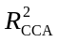 | 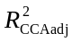 | F-ratio | p-value
Factors (q)
site (19) | year + management | random shuffle | 0.50 | 0.46 | 13.471 | 0.001
year (10) | site + management | toroidal shift | 0.04 | < 0.01 | 2.248 | 0.001
management variables (3) | site + year | random shuffle | 0.01 | < 0.01 | 2.145 | 0.001
-- | -- | toroidal shift | -- | -- | -- | 0.001
Site Specific Variables
log Ca | slope + northness + year + management | random shuffle | 0.13 | 0.12 | 19.735 | 0.001
slope | log Ca+ northness + year + management | random shuffle | 0.03 | 0.03 | 8.152 | 0.001
northness | log Ca + slope + year + management | random shuffle | 0.02 | 0.01 | 5.219 | 0.001
Management Variables
years of bison | years since last burn + # of burns in 5 years + site + year | random shuffle | < 0.01 | < 0.01 | 2.314 | 0.001
-- | -- | toroidal shift | -- | -- | -- | 0.001
years since burn | years of bison + # of burns in 5 years + site + year | random shuffle | < 0.01 | < 0.01 | 2.102 | 0.001
-- | -- | toroidal shift | -- | -- | -- | 0.001
# of burns in 5 years | years of bison + years since last burn + site + year | random shuffle | < 0.01 | < 0.01 | 1.616 | 0.001
-- | -- | toroidal shift | -- | -- | -- | 0.021
* random shuffle permutations were constrained to occur within a year, toroidal shifts were constrained within a given a site and preserved the temporal order of samples (see Methods for more explanation)
Figures
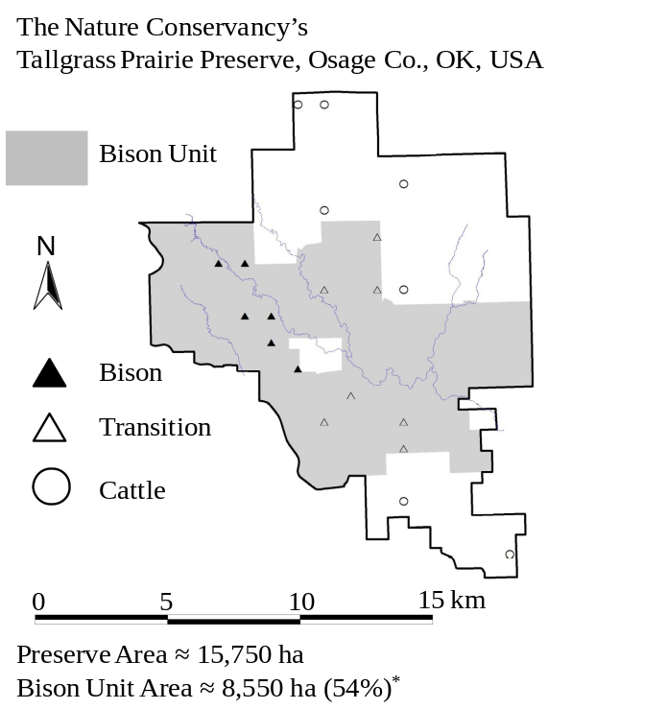
Fig. 1. A map of the Tallgrass Prairie Preserve. The shaded area denotes the bison unit which increased in area during the duration of the study. The twenty quadrats sampled each year of this study are displayed on the map. The sites that were bison at the beginning of the study (1998) are displayed with filled triangles (▲), those that transitioned during the study from cattle to bison are denoted by unfilled triangles (Δ), and the other cattle grazed samples are denoted by unfilled circles (○). *Area of bison unit is as of May 1, 2008.
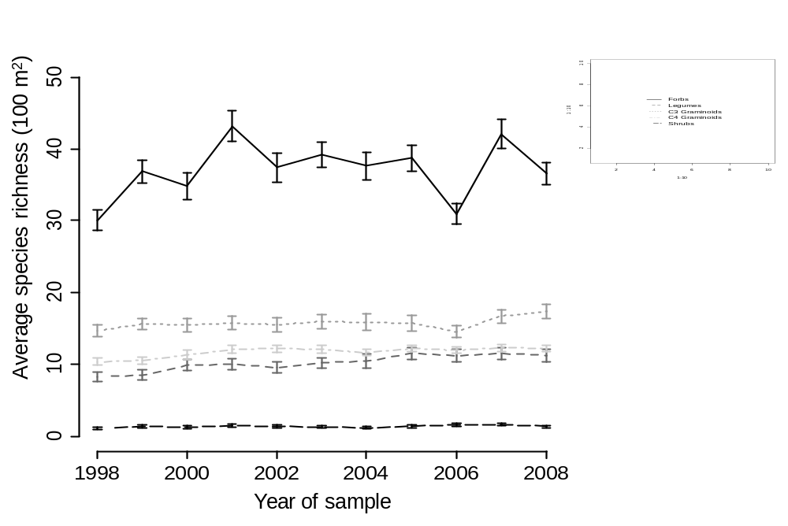
Fig 2. The average species richness of four functional groups: forbs (that are not legumes), legumes, C3 graminoids (grasses, sedges, and rushes), and C4 graminoids over the course of the study. The error bars display ± 1 standard error.
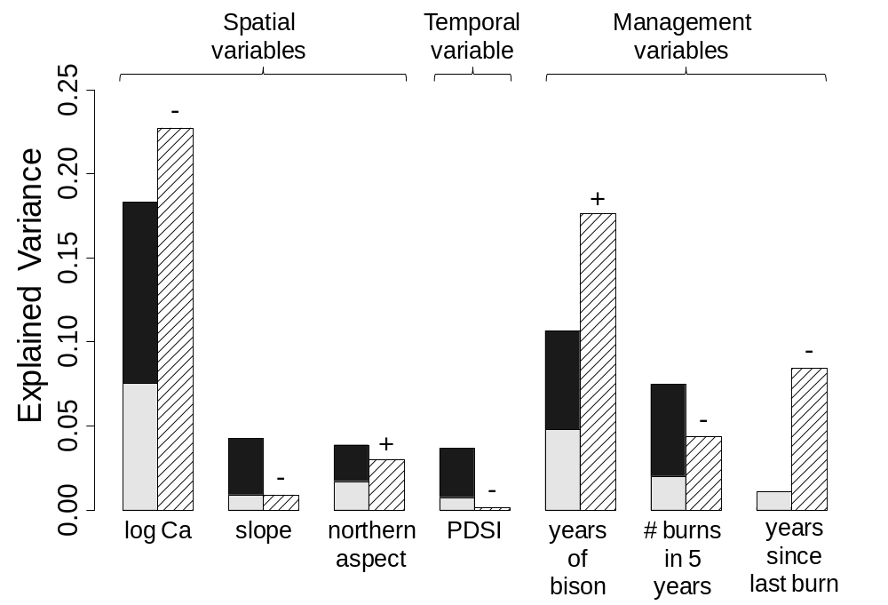
Fig. 3.
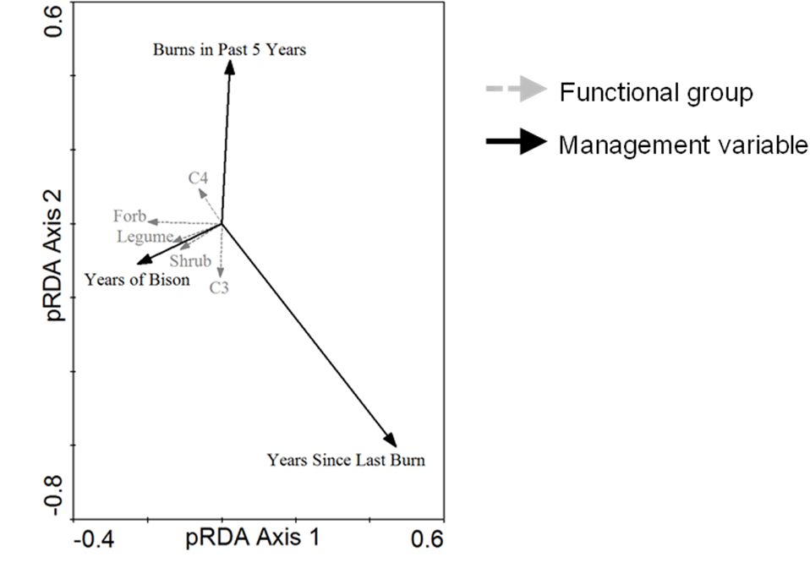
Fig. 4. A pRDA biplot of the richness of each functional group against the management variables after factoring out site and year effects. The management variables explained a significant amount of variance in the functional groups (R² = 0.12, 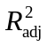= 0.10, F-ratio = 8.46, p-value = 0.001 after 999 torodial shifts within a site or random shifts within a year).
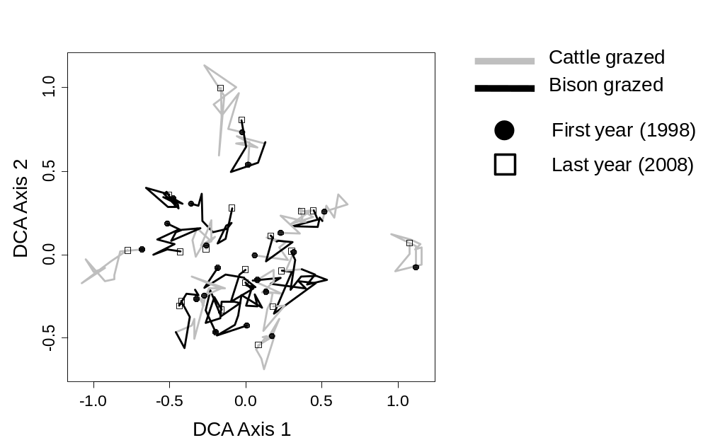
Fig. 5. DCA scatterplot (the eigenvalues were 0.152 and 0.108 for the first and second axis respectively) displaying the 20 quadrats from 1998 to 2008. The time series is indicated by a line segment (—) with joints at each year, a dark black line joins years in which the plot experienced bison grazing and a grey line demarcates years in which the plot experienced cattle grazing. The 1998 samples are indicated by circles (●) and the 2008 samples are indicated by squares (□).
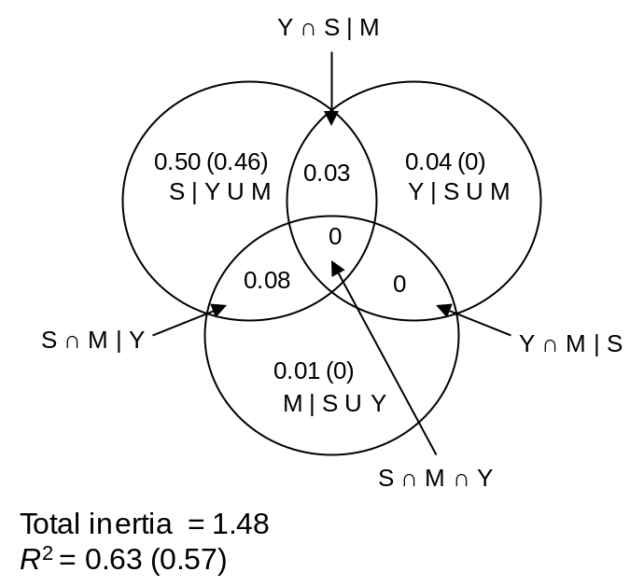
Fig. 6. A Venn diagram displaying the R² () of each fraction resulting from the variation partitioning of species composition using CCA. The three factors (classes of explanatory variables) were site (S), year (Y), and management (M). Note that R² in this context should not be interpreted as fraction of explained variance but rather fraction of explained inertia. For the shared fractions we only report the unbiased values.
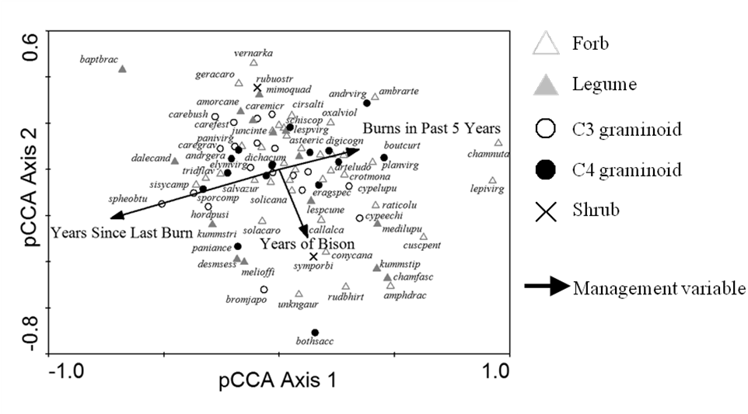
Fig. 7. A pCCA biplot displaying the influence of the management variables with the sites and years as covariables. The management variables in the model are indicated by black arrows. Only the 90 most abundant species of the 307 total are displayed for clarity. Abbreviations represent the first four letters of the genus and the first four of the letters
of the species (see Appendix #). The symbol of each species depends on which functional type it belongs to (see legend).
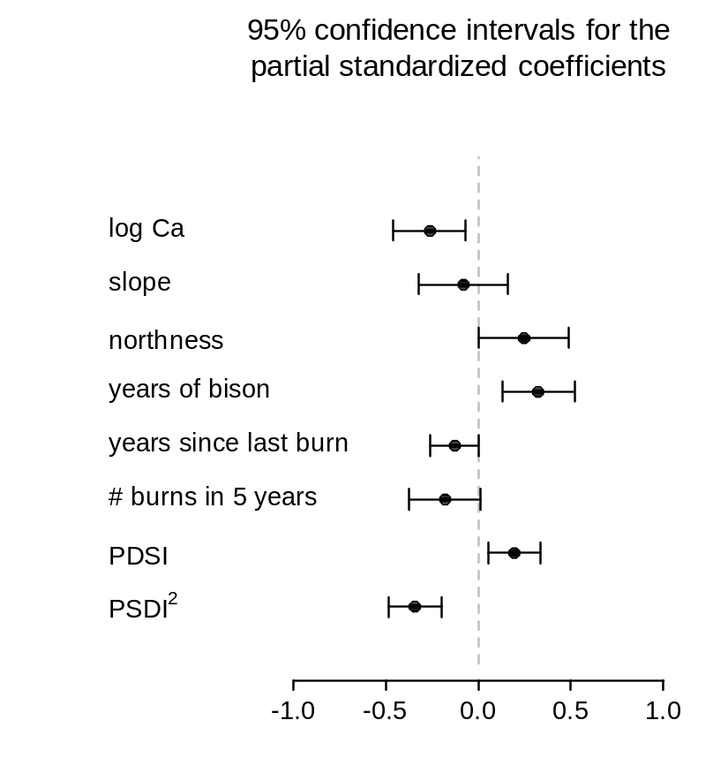
Fig. # . The approximate 95% confidence intervals for the standardize coefficients of a GLS model with a quadratic rational model (range = 6.9_{3.2,15.04} , nugget = 0.5_{0.4,0.6}) to consider within site temporal autorcorrelation in the residuals of the model.

